Step-by-step Installation of CompuCell3D on Windows (May 2022)
May 2022, CC3D 4.3.0v2 on Windows 10
When installing CompuCell3D on Windows the operating system will complain that the software package is unrecognized. If you get a pop-up window like the one shown below you will need to instruct Windows to continue the installation.
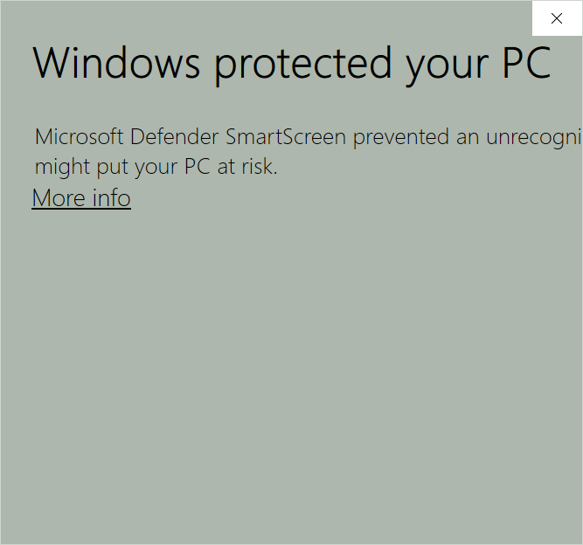
First, you need to expand the window to see the options. Drag the bottom right corner to show the hidden options.
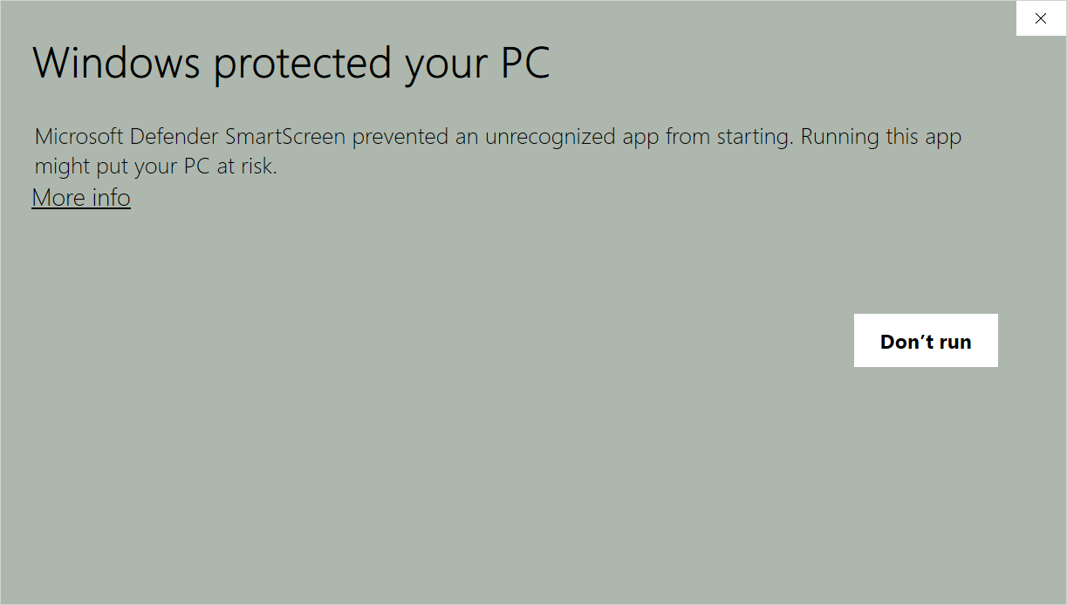
Click "More info" text to show the option to install anyway.
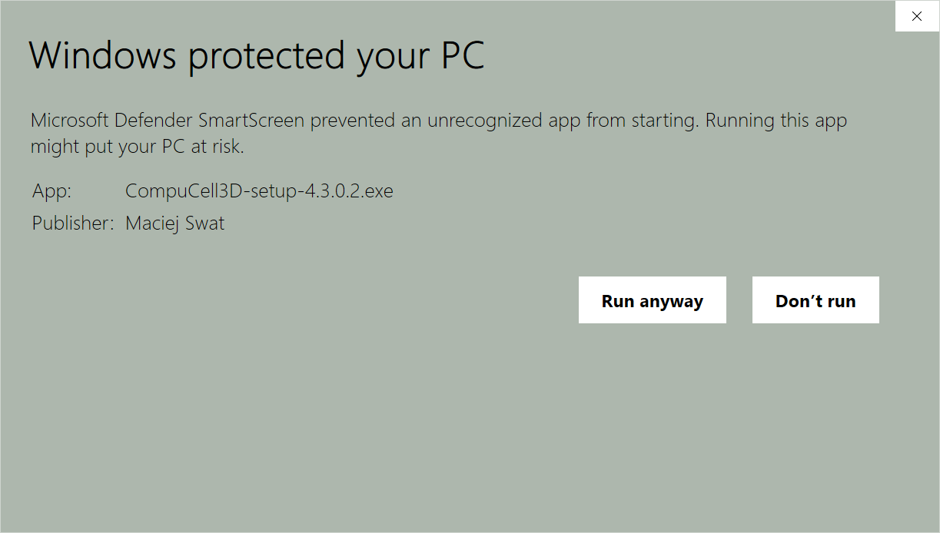
Click "Run anyway" button.
Windows will then ask for permission to install software
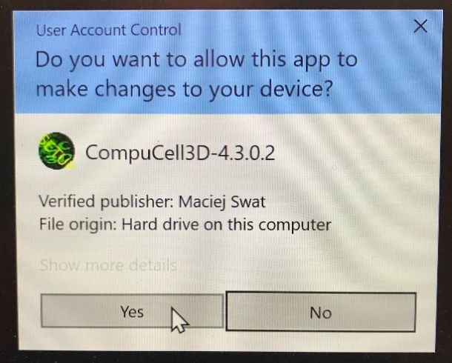
Click "Yes"
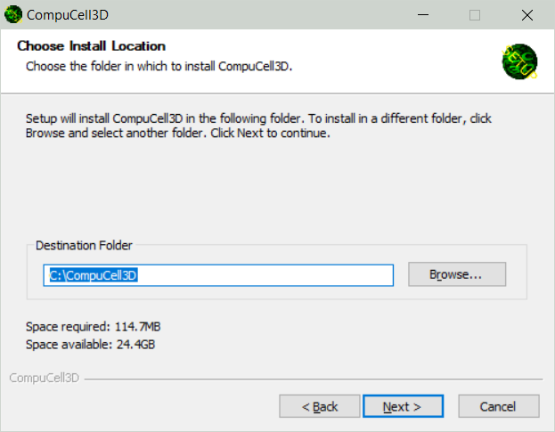
Usually the default location is OK, click "Next"
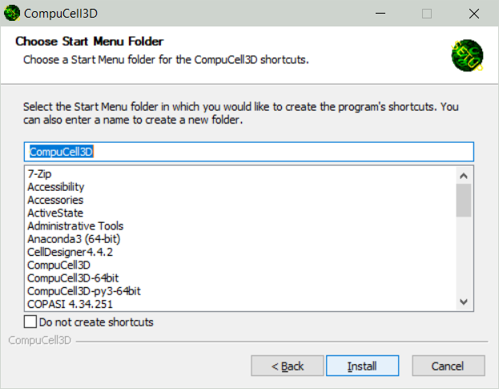
Click "Install"
The actual install will take several minutes. Progress is shown in a command window.
You may need to locate the command window (shown below) and enter a final carriage return to finish the installation.
This will give the "Completed" window
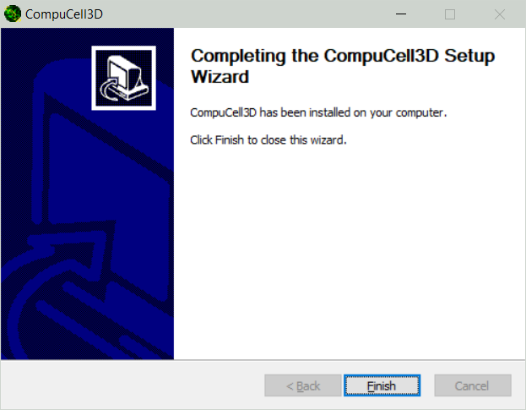
Click "Finish".
The installer should make shortcuts for Twedit++ and CompuCell3D. If not, you can make links to the appropriate batch files in C:\CompuCell3D. For example, "compucell3d.bat" and "twedit++.bat".

jps

